**HOMEWORK 8**

**1. Describe the three types of actuators that are commonly used with the RPi.**

**Ans:**

A device that can convert into motion is called Actuators. Generally, there are three type of actuators used with Raspberry Pi i.e. Servo motor, DC motor and Stepper motor. We discuss each motor one by one in explanation.

**Servo motor:**

Servo motor is used when high torque and accurate rotation is required. The position of servo motor can be controlled by sending pulse width modulation (PWM) signal. This signal can be generated by using controller or by simple tuning. The control of servo type is feedback-controlled system so if we set the specific angle in the programming the controller will move the servo motor to that specified angle. The application of servo motor is in small application like camera control, robotic arm and steering control.

**DC motor:**

DC motor are used when fast rotation is required. The speed of DC motor is controlled by using PWM while some additional circuitry is required to meet the power criteria for driven motor. The speed of DC motor is controlled by feedback-controlled loop from optical encoder. The torque of motor is very high which helps a lot to drive large loads. The application of DC motor is in robots, electric cars, fan and pump.

**Stepper motor:**

Stepper motor is used when slow speed and accurate rotation is required. For driving the stepper motor a controller is required to energize the coils of DC motor. The raspberry pi can energize the coils but it is better if some external controller is used for this purpose. The stepper motor control is mostly open loop because the rotation is precise and steps are counted. Stepper motor are used when large torque but low speed is required. The application of steppers motor are camera lenses, printers and CNC machines.

**2. Complete the Driving Small DC Motors (up to 1.5A) section in chapter 10, page 410 – 412. Copy the**

**results of the test for your answer and give a picture/video of your program as it executes.**

**Ans:**

**Result of the test:**

Motor A: Rotate forward at 50% for 5 seconds

Motor A: Rotate backwards at 100% for 5 seconds

Motor B: Rotate forward at 75% for 5 seconds

Motor B: Rotate Backwards at 25% for 5 seconds

End of Program turn off both motors

**Picture of program execution:**

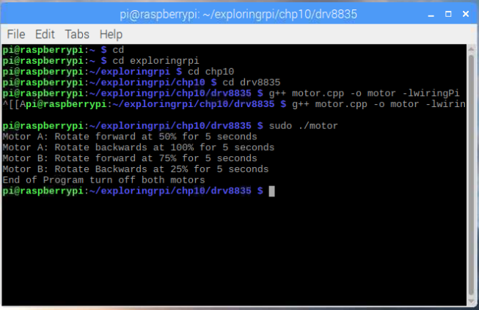

**3. Complete the Makefiles section in chapter 10, page 444 – 445. Copy the results of the test for your answer and give a picture/video of your program as it executes.**

**Ans:**

#!/bin/bash

g++ -o3 hello.cpp -o hello

g++ -o3 test.cpp -o test

all: hello test

hello:

g++ -o3 hello.cpp -o hello

test:

g++ -o3 test.cpp -0 test

g++ -o3 hello.cpp -o hello

g++ -o3 test.cpp -0 test

**Picture of program execution:**

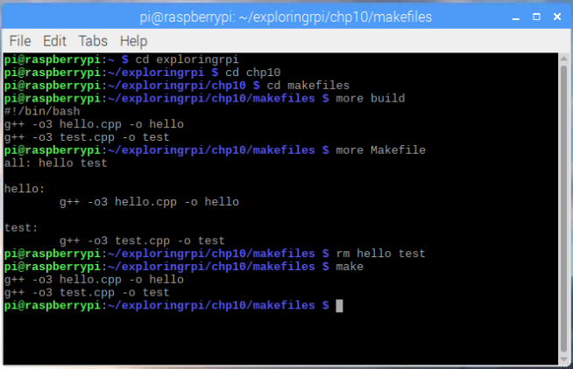

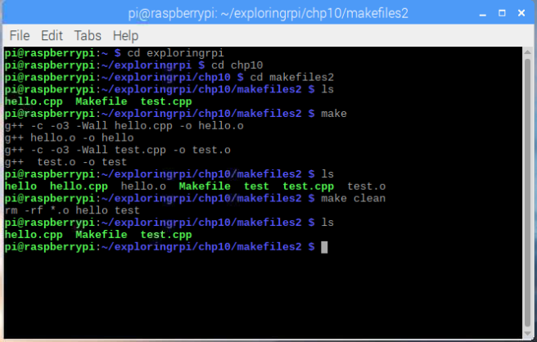

**4. Complete the Building a C/C++ Library section in chapter 10, page 447 – 450. Copy the results of the test for your answer and give a picture/video of your program as it executes**

**Ans:**

**Result of the test:**

pi@raspberrypi:~ $ cd exploringrpi

pi@raspberrypi:~/exploringrpi $ cd library

pi@raspberrypi:~/exploringrpi/library $ mkdir build

pi@raspberrypi:~/exploringrpi/library $ cd build

pi@raspberrypi:~/exploringrpi/library/build $ cmake ..

-- The C compiler identification is GNU 6.3.0

-- The CXX compiler identification is GNU 6.3.0

-- Check for working C compiler: /usr/bin/cc

-- Check for working C compiler: /usr/bin/cc -- works

-- Detecting C compiler ABI info

-- Detecting C compiler ABI info - done

-- Detecting C compile features

-- Detecting C compile features - done

-- Check for working CXX compiler: /usr/bin/c++

-- Check for working CXX compiler: /usr/bin/c++ -- works

-- Detecting CXX compiler ABI info

-- Detecting CXX compiler ABI info - done

-- Detecting CXX compile features

-- Detecting CXX compile features - done

-- Looking for pthread.h

-- Looking for pthread.h - found

-- Looking for pthread_create

-- Looking for pthread_create - not found

-- Looking for pthread_create in pthreads

-- Looking for pthread_create in pthreads - not found

-- Looking for pthread_create in pthread

-- Looking for pthread_create in pthread - found

-- Found Threads: TRUE

-- Configuring done

-- Generating done

-- Build files have been written to: /home/pi/exploringrpi/library/build

pi@raspberrypi:~/exploringrpi/library/build $ make

Scanning dependencies of target ExploringRPi

[ 5%] Building CXX object CMakeFiles/ExploringRPi.dir/CMakeFiles/3.7.2/CompilerIdCXX/CMakeCXXCompilerId.cpp.o

[ 11%] Building CXX object CMakeFiles/ExploringRPi.dir/bus/BusDevice.cpp.o

[ 16%] Building CXX object CMakeFiles/ExploringRPi.dir/bus/I2CDevice.cpp.o

[ 22%] Building CXX object CMakeFiles/ExploringRPi.dir/bus/SPIDevice.cpp.o

[ 27%] Building CXX object CMakeFiles/ExploringRPi.dir/display/LCDCharacterDisplay.cpp.o

[ 33%] Building CXX object CMakeFiles/ExploringRPi.dir/display/SevenSegmentDisplay.cpp.o

[ 38%] Building CXX object CMakeFiles/ExploringRPi.dir/docs/front_page.cpp.o

[ 44%] Building CXX object CMakeFiles/ExploringRPi.dir/gpio/GPIO.cpp.o

[ 50%] Building CXX object CMakeFiles/ExploringRPi.dir/gpio/PWM.cpp.o

[ 55%] Building CXX object CMakeFiles/ExploringRPi.dir/gpio/util.cpp.o

[ 61%] Building CXX object CMakeFiles/ExploringRPi.dir/motor/DCMotor.cpp.o

[ 66%] Building CXX object CMakeFiles/ExploringRPi.dir/motor/Servo.cpp.o

[ 72%] Building CXX object CMakeFiles/ExploringRPi.dir/motor/StepperMotor.cpp.o

[ 77%] Building CXX object CMakeFiles/ExploringRPi.dir/network/SocketClient.cpp.o

[ 83%] Building CXX object CMakeFiles/ExploringRPi.dir/network/SocketServer.cpp.o

[ 88%] Building CXX object CMakeFiles/ExploringRPi.dir/sensor/ADXL345.cpp.o

[ 94%] Building CXX object CMakeFiles/ExploringRPi.dir/sensor/ITG3200.cpp.o

[100%] Linking CXX shared library libExploringRPi.so

[100%] Built target ExploringRPi

pi@raspberrypi:~/exploringrpi/library/build $ ls -l *.so

-rwxr-xr-x 1 pi pi 111868 Jul 11 07:36 libExploringRPi.so

pi@raspberrypi:~/exploringrpi/library/build $ sudo make install

[100%] Built target ExploringRPi

Install the project...

-- Install configuration: "Release"

-- Installing: /usr/lib/libExploringRPi.so

pi@raspberrypi:~/exploringrpi/library/build $ ls -l /usr/lib/libExploringRPi.so

-rw-r--r-- 1 root root 111868 Jul 11 07:36 /usr/lib/libExploringRPi.so

pi@raspberrypi:~/exploringrpi/library/build $

**Picture of Program execution:**

